Pokhara University

Level: Bachelor | Semester – Spring | Year : 2014
Programme: BE |  | Full Marks : 100
Course: Object Oriented Design and Modelling through UML |  | Time : 3hrs.

Candidates are required to give their answers in their own words as far as practicable.
The figures in the margin indicate full marks.

Attempt all the questions.

 | - Explain different phases and disciplines of Rational Unified Process?  - What are the important components of a use case model? Illustrate the importance of use case diagram for a system being developed. | 6  9
 | - What are the different methods of identifying use cases? List the difference between essential and real use cases with suitable examples  - Associations and attributes are essential components of a conceptual model. Do you agree or disagree? Justify your opinion. | 8  7
 | - What is a collaboration diagram? How do we represent mutually exclusive conditions in a collaboration diagram? Justify with an example.  - What do you mean by system behaviour? List its types. Explain the guidelines for preparing a contract. | 7  8
 | - What are the GRASP patterns? Explain with an example how you apply the creator pattern during object design.  - Why is class diagram important? Explain the structure of a class diagram with a necessary figure. Also list the difference of a Class diagram during analysis phase and design phase. | 8  7
 | - What is a Contract? How do you derive a contract? What are the essential parts of a contract? Explain its role taking an example.  - What do you understand by updating of class definitions? Illustrate with an example. | 8  7
 | - Convert the given Design Class Diagram into an equivalent code. (you can choose any language like Java, C++, etc)  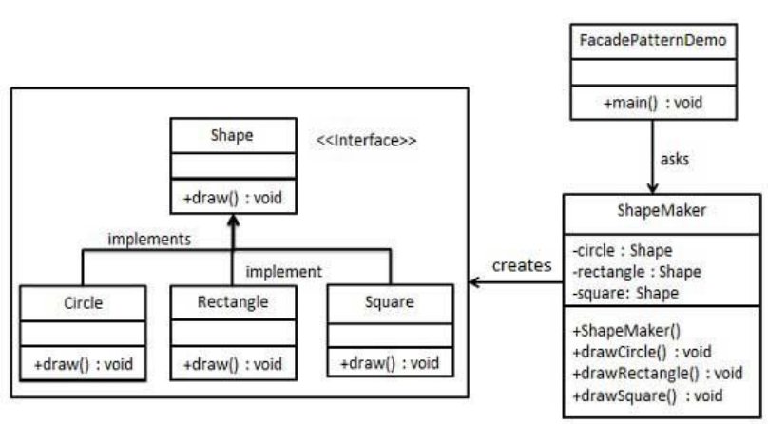  - What do you understand by three tier architecture? How this architecture can be deployed in various configurations? | 10
 | Write short notes on (Any Two)  - Visibility  - Domain Analysis  - Exceptions and error handling | 5×2

